Computer Networks Notes

CS3006D

4 credits

Module 1&2 - Hiran - Jan & Feb

Module 3&4 - PARK sir - March & April

|  |
| --- |
|  |

# 1. Introduction

11.01.2021

10:15-10:30am

* Forms a support/background for cryptography, blockchain, and many other subjects. Hence it is a core course.
* The Computer Networks course is completely unrelated to the Networks Lab.
  + Separate course plan, assignments, everything.

## 1.1. Objectives

|  |
| --- |
|  |

* Understanding protocols used in computer networks, the architecture of the internet and connected devices, etc.

|  |
| --- |
| **Note:** ISO/OSI and TCP/IP (more commonly used, 5 layers, can be compressed to 4 layers also) standard protocol stacks |

## 1.2. References

|  |
| --- |
|  |

* In Kurose-Ross, Hiran sir’s part is the first 4 chapters.

## 1.3. Evaluation Policy

|  |
| --- |
|  |

### 1.3.1. Assignment 1

Assignment 1a: Transfer protocols

Assignment 1b: Routing/internetworking

Assignments - in groups of 5 persons each

### 1.3.2. Quiz 1

Dates as in Course Plan.

### 1.3.3. Assignment 2 and Quiz 2

Will be given by PARK sir

|  |
| --- |
|  |

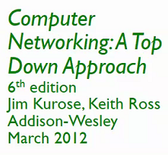

# 2. Introduction: Pt 2

13/01/2021

11:15-12 pm

## 2.1. Overview -

* What’s the Internet?
* What’s a protocol?
* Network edge; - hosts, access net, physical media
* Network core; - packet/circuit switching, internet structure
* Performance; - loss, delay, throughput
* Security
* Protocol layers, service models
* History

## 2.2. What is the Internet

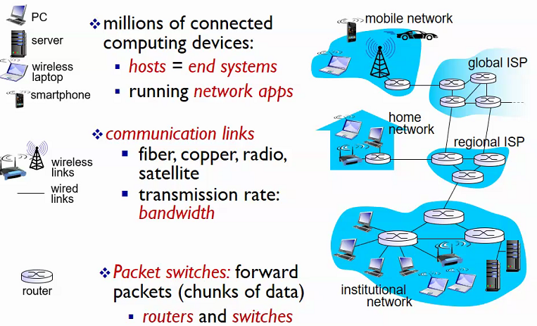

* First Internet -
  + **ARPANet**
  + Advanced Research P_ A_ Network
  + US Funded
* If you want to start a network
  + Find a service provider, to give an IP address and server connectivity.
  + Nonprofit regional organizations that allot such things is your best bet. Three main organizations handle this in India
  + **IRINN** - An organization responsible for allocating IP addresses.
    - Internet Registry something something
    - Responsible for internet service provision in India
    - Gives internet names and numbers (IP address, taken from APNic)
  + **APNic -** A nonprofit responsible for internet service providers in the Asia-Pacific (AP) region.
  + **National Internet Exchange of India (NIXI)** - “An Internet Exchange Point is a facility that allows Internet Service Providers to "meet" and exchange traffic, also called peering.”

## 2.3. IP Addresses

|  |
| --- |
| **What is an IP address?**  The Internet service provider gives you a 32 bit no. that uniquely identifies you in that network.  ‘Internet Protocol address’ |

* **IP addresses are divided based on region.**
* Global players in IP ranges -
  + These global players allot ranges of IP addresses to regional Nics all over the world, like **APNic**, which in turn would give it to **IRINN** and the other, smaller regional providers
* This whole network of IP addresses is what forms the Internet.

## 2.4. ‘Hosts’ or End Systems

* In networking jargon, a computer connected to a computer network is sometimes referred to as an end system or end station.
* End systems that are connected to the Internet are also referred to as Internet hosts.
  + This is because they host (run) Internet applications such as a web browser or an email retrieval program.
* **Note:** A client and server networking model is a model in which computers such as servers provide the network services to the other computers such as clients to perform user-based tasks.

##### Servers

The server runs one or more programs that share resources and distribute work among clients.

##### Clients

The client relies on sending a request to another program in order to access a service made available by a server.

## 2.5. Routers, Hubs, and Switches

* All of these are intermediary devices/systems in a network.
* We will examine these in more detail in the next class.

# 3. Practical/Hardware View

14.1.2021

8-8:45 am

When communicating between systems, signals are sent in the form of electrical signals. Ofc there will be resistances while doing do, ie, wire resistance, etc. For this purpose, to eliminate this resistance, we have routers, hubs, and switches.

Various cables existing in an ethernet (CAT) cable are shown in the image to the left.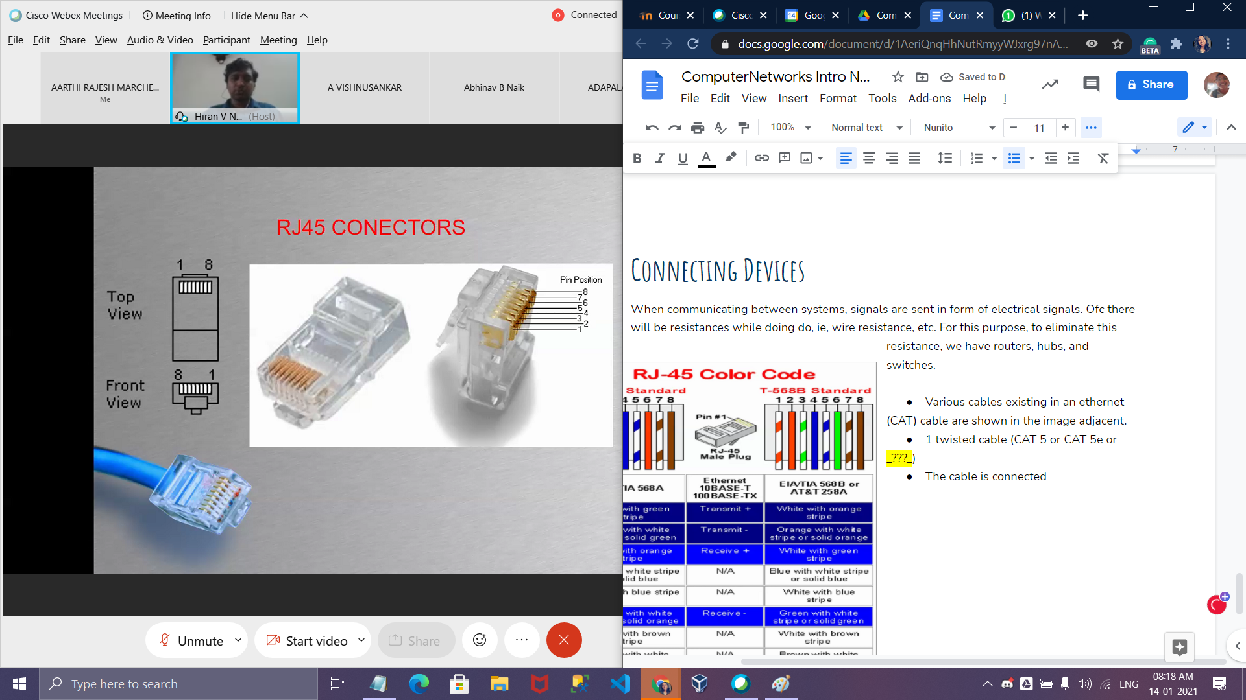

* 1 twisted cable (CAT 5 basic 100mbps or CAT 5e or _???_)
* Old network cards are slow. If they are slow, CAT 5e is useless. Network card speeds can be controlled.
* The cable is connected to the Nic card via **RJ45 connectors**, via a process called crimping.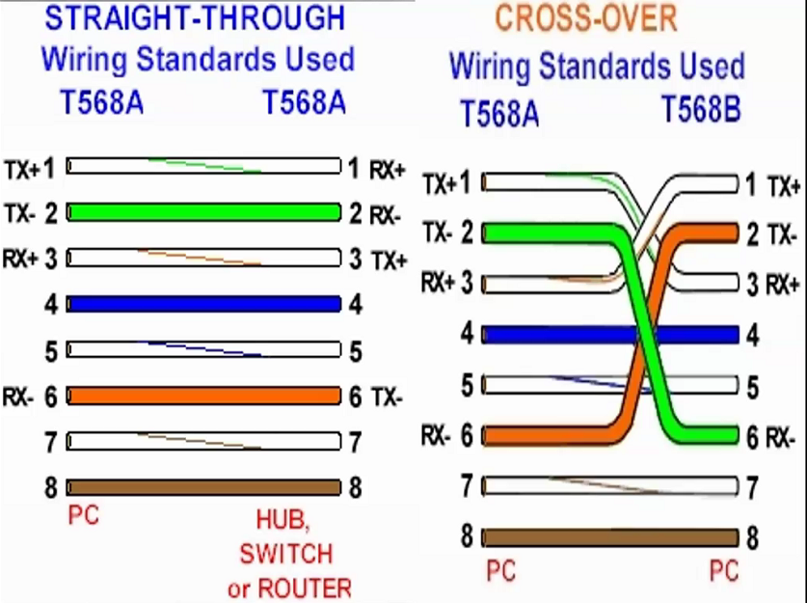
* In the Wire Standards diagram, TX=>Transmitter, and RX=>Receiver.
  + Crossover implies the transmitter pin of one system connects to the receiver of another system, and the receiver pin of the first system connects to the transmitter of the second.

## 

## 

## 3.1. Ethernet MDI MDIX Auto Cross

* Normally, twisted-pair ports must be connected so that the transmit-pair on one end is connected to the receive-pair on the other end, and vice versa.
  + If the cabling is done such that

## 3.2. Connecting Using a Hub

Note: Presently, we do not use hubs due to certain issues. We will examine hubs in detail in modules 3 & 4, with PARK sir, but for now, we will talk about them briefly.

---

## 3.3. Hubs

A device used for setting up a network connection, alongside switches. It is a repeater/amplification device.

Say we need to send a file between 2 systems, say from system #1 to system #50. All the systems will be connected to one or more hubs, in a cascading manner.

#1 has 4 cables (TX+, TX-, RX+, RX-). It’ll send the data via the TX+ and TX- cables to the hub. Hub is just an amplifying/repeating device. It will just amplify the signal and send it to **all** the RX+ and RX- cables connected to it.

=> **All** the 50 systems will be getting this signal.

Obviously, there are a few problems with this:

Congestion: All the machines are receiving this data => they can’t receive any other data during this time.

Security: Data meant for one particular system goes to **every** system. Additionally, in case one system is malicious, the harmful signal reaches the entire set of systems.

To fix the above problems, switches came about.

**Note:** In a single port, we should have a minimum of 4 pins, so that 2 can be used for transmission and 2 for receiving.

## 

## 3.4. Switches - is a packet switch: forward chunks of data

Switches operate at a data link layer. They connect devices over a network and utilize ARPTs (see below) and packet switching to send/receive/forward data over a network.

* Initially, 47 systems will be connected in the **NEs**(Network Embedded System) switch, by connecting one switch **uplink port...**

|  |
| --- |
| * + An **uplink port** is a port on a router or switch designed to connect to another router or switch or an Internet access device. The uplink port **reverses the transmit and receive connectors**. |

* + **...**to any port in the other switch (not necessary to connect to specifically the uplink port of the other switch). This will use a straight-through cable, as the internal pins get changed in uplink ports. Nowadays this connection happens automatically (See **Auto-Uplink Switches**).
* It keeps an Address Resolution Protocol Table (**ARPT**, we will see in detail with PARK sir) and checks to which cable the data needs to be transmitted, transmitting only to that particular cable. In this way, it differs from hubs and fixes the main problems they present.
* No dedicated communication link.

### 18 Jan 2021

## 3.5. Router - it is a packet switch

* Interconnects 2 different networks.
* A router is a hardware device designed to receive, analyze and move incoming packets to another network. It may also be used to convert the packets to another network interface, drop them, and perform other actions relating to a network.
* Cascading routers: 1 router to another
* Global ISPs: connects b/w regional ISPs

## 3.6 WHAT IS A PROTOCOL?

* A communication protocol is a system of rules that allow two or more entities of a communications system to transmit information via any kind of variation of a physical quantity.
* The protocol defines the rules, syntax, semantics, and synchronization of communication and possible error recovery methods

Protocol layers:

1. Hosts
2. Routers
3. links/various media
4. Applications
5. hardware/ software

### 3 Feb 2021

# 4. The HTTP Protocol

**RTT (definition):** Round Trip Time - the time taken by a packet to travel from client to server and back.

## 4.1. Types of HTTP

1. **Non-Persistent HTTP:** A new TCP connection is opened for every request. Takes 2 RTTs for each request
2. **Persistent HTTP:** After the first request, the TCP connection is kept open for subsequent requests. Takes as low as 1 RTT for each request.

## 4.2. Breaking down an HTTP request

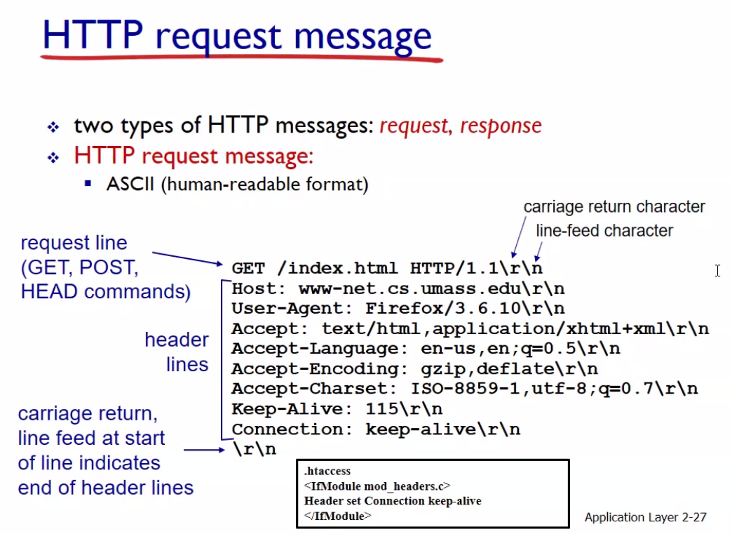

## 4.3. HTTP request types

* **GET:** (Sometimes called URL method) request made with all the data inside the URL
* **POST:** Form data is added to the request apart from the URL and other data.

## 4.4. HTTP versions

1. **HTTP/1.0**
   1. GET
   2. POST
   3. HEAD: asks the server to leave the requested object out of response
2. **HTTP/1.1**
   1. GET
   2. POST
   3. PUT: update data to body specified at the URL
   4. DELETE: delete files specified by the URL

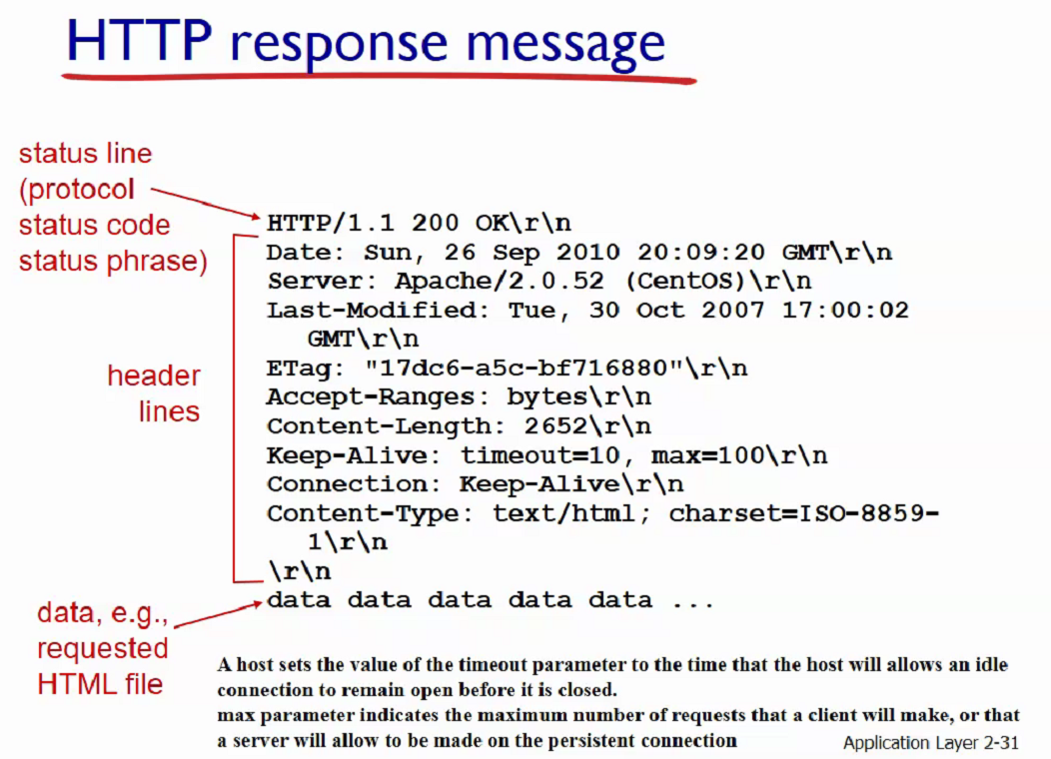

Tbk notes

# Chapter - 1: COMPUTER NETWORKS AND THE INTERNET

## WHAT IS A COMPUTER NETWORK?

* Computer Network is a group of computers connected with each other through wires, optical fibres or optical links so that various devices can interact with each other through a network.
* To share the resources among various devices
* Server types of networks

Basic characteristics of computer networks:

1. Fault tolerance
2. Scalability
3. Quality of service
4. security

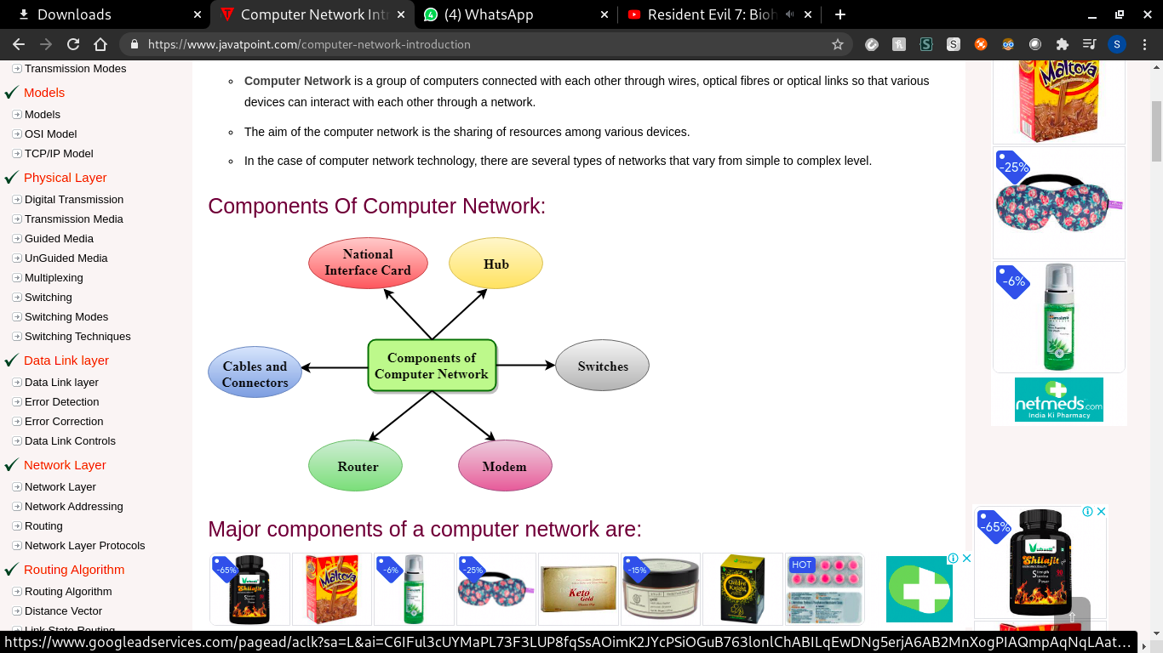

## Major components of a computer network:

### NIC(NATIONAL INTERFACE CARD):

* It is a device that helps the computer to communicate with another device.
* Contains the ***hardware address***, the data link layer protocol uses this address to identify the system on the network.
* 2 types. Wireless (Using the antenna )and wired

### HUB

* Hub splits the network connection into multiple devices.
* When a computer requests for information from a computer, it sends the request to the Hub. Hub distributes this request to all the interconnected computers.

### SWITCHES (better than hub)

* Switch is a networking device that groups all the devices over the network to transfer the data to another device.
* A switch is better than Hub as it does not broadcast the message over the network, i.e., it sends the message to the device for which it belongs to.
* Therefore, we can say that switch sends the message directly from source to the destination

### Cables and connectors

Cable is a transmission media that transmits the communication signals. There are three types of cables:

**Twisted pair cable**: It is a high-speed cable that transmits the data over 1Gbps or more.

**Coaxial cable**: Coaxial cable resembles a TV installation cable. Coaxial cable is more expensive than twisted pair cable, but it provides a high data transmission speed.

**Fibre optic cable**: Fibre optic cable is a high-speed cable that transmits the data using light beams. It provides high data transmission speed as compared to other cables. It is more expensive as compared to other cables, so it is installed at the government level.

### ROUTER

* Router is a device that connects the LAN to the internet.
* The router is mainly used to connect the ***distinct networks*** or connect the internet to multiple computers.

### MODEM

* Modem connects the computer to the internet over the existing telephone line.
* A modem is not integrated with the computer motherboard. A modem is a separate part on the PC slot found on the motherboard.

***What is a protocol?***

* All communication schemes will have the following things in common
* Source or sender
* Destination or receiver
* Channel or media

Rules or protocols govern all methods of communication. It determines

* What is communicated
* How is it communicated
* When is it communicated

Ex: Protocols that are necessary for human communication include: identified sender and receiver, common language and grammar, speed and timing of delivery, confirmation and acknowledgement requirements

***Protocols used in network also define: basically the rules - elements of the protocols***

1. Message encoding

Message source -> encoder(signal) -> Transmitter -> transmission medium -> receiver -> decoder -> message destination

1. Message formatting and encapsulation:

Encapsulate the info to identify the sender and receiver correctly

1. Message timing

* Flow control: fast sender, slow receiver => useless
* Response timeout: wait for the acknowledgement, if no acknowledgement, send again. Amt of time to wait

1. Message size

Long message is divided into smaller ones and sent based on the capacity of the medium

1. Message delivery options

* Unicast : 1 sender - 1 receiver
* Multicast: set of receivers
* Broadcast: to all the participants in the networks

## Peer to peer network:

* No centralized administration
* All peers are equal
* Simple sharing applications
* Not scalable

## Client server network

* Centralized application
* Request- Response model
* Scalable
* Server may be overloaded.

## Components of a computer network

* Nodes : a device which is capable of sending/receiving data generated by other nodes in the network; connected by communication links. Can be either wired or wireless.

1. End nodes: Computers, phones etc. start or end
2. Intermediary nodes: Switches, bridges, routers, etc. pass info bw nodes

* Media: Link

1. Wired Medium: guided.

Ex: Ethernet st- cable(diff nodes). Ethernet crossover cable(same types). Fiber optic cable(Light waves), coaxial cable(audio, electrical signal), usb cable.

1. Wireless medium: unguided

Ex: Infrared: short range

Radio: bluetooth, wifi

Microwaves: cellular system

Satellite: long range communication - GPS

* Services

Email, storage devices, online games, etc.

## COMPUTER NETWORKS: A BOTTOM UP APPROACH

1. LAN: local area network, small area. School or stuff; Ethernet - Hub and switch.
2. MAN: metropolitan area network: bunch of lans in a city; connected to each other using a router.
3. WAN: wide area network: end devices and internet; telecommunication network
4. Internet:everything together
5. Storage area network:

Cloud computing: on demand availability of computer system resources, especially data storage and computing power. Without direct management by the user.

## 

## 

## BASICS OF IP ADDRESSING:

* Internet protocol
* Every node has an ip address
* Logical address : changes based on the location and place; manual or dynamic
* Can change based on the location
* Every lan has an ip
* 4 octets
* X.x.x.x : 0.0.0.0 to 255.255.255.255 (32 bits) //has to be decimal

## BASICS OF mac addressing

* Media access control
* Ip = location of a person
* Mac ; name

# PROTOCOL LAYERS AND SERVICE MODELS

Layering: there are layers

Node is a communication endpoint

Full duplex. Half duplex. simplex

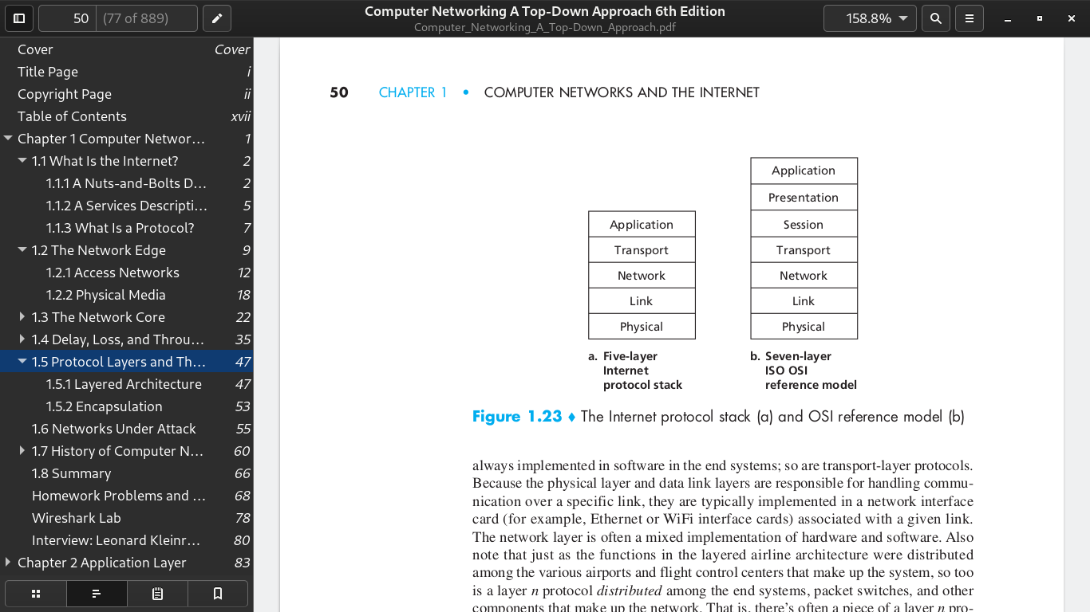

Data Link and Physical layers are for handling communication over a specific link, over NIC.

The protocols on various layers are called the protocol stack

## Application layer

* Protocols such as HTTP, SMTP, FTP
* Distributed over various end systems.